Part Number: PT738-78150

Kit Contents
Item # | Quantity Reqd. | Description
1 | 1 | Rear Bumper Protector
2 | 1 | Installation Instructions
3
Hardware Bag Contents
Item # | Quantity Reqd. | Description
1
2
3
Additional Items Required For Installation
Item # | Quantity Reqd. | Description
1
2
3
Conflicts
Recommended Tools
Personal & Vehicle Protection | Notes
Safety Glasses
Seat & Floor Covers
Special Tools | Notes
Roller | Hard Rubber or Wooden  Hand Roller, 1” to 3” Wide
Installation Tools | Notes
Clean, Lint-Free Cloth
Special Chemicals | Notes
Cleaner | VDC Approved
General Applicability
All Models
Recommended Sequence of Application
Item # | Accessory
1
2
3
*Mandatory
Vehicle Service Parts (may be required for reassembly)
Item # | Quantity Reqd. | Description
1
2
3
Legend
STOP: Damage to the vehicle may occur. Do not proceed until process has been complied with.
OPERATOR SAFETY: Use caution to avoid risk of injury.
CAUTION: A process that must be carefully observed in order to reduce the risk of damage to the accessory/vehicle and to ensure a quality installation.
TOOLS & EQUIPMENT: Used in Figures calls out the specific tools and equipment recommended for this process.
REVISION MARK: This mark highlights a change in installation with respect to previous issue.
SAFETY TORQUE: This mark indicates that torque is related to safety.

Care must be taken when installing this accessory to ensure damage does not occur to the vehicle. The installation of this accessory should follow approved guidelines to ensure a quality installation.

These guidelines can be found in the "Accessory Installation Practices" document.

This document covers such items as:-
- Vehicle Protection (use of covers and blankets, cleaning chemicals, etc.).
- Safety (eye protection, rechecking torque procedure, etc.).
- Vehicle Disassembly/Reassembly (panel removal, part storage, etc.).
- Electrical Component Disassembly/Reassembly (battery disconnection, connector removal, etc.).

Please see your Toyota dealer for a copy of this document.

Prepare the Vehicle.
  - Open the rear lift gate.
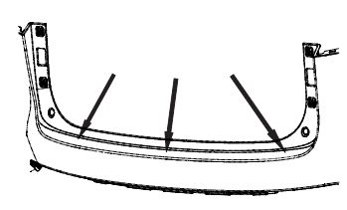
  - Clean the bumper surface with VDC approved cleaner (Fig. 1-1).
Fig. 1-1
Clean this surface
  - Wipe the scrubbed bumper surface with a clean, dry, lint-free cloth.
NOTE: Once cleaned, do not contaminate surface by touching with your bare hands.

Install the Bumper Protector.
  - Carefully hold the bumper protector by its edges and pull the plastic tape at the end of the part to remove the liner from the foam tape.
NOTE: Once the release liner is removed from the bumper protector, the surface of the tape must not be touched.
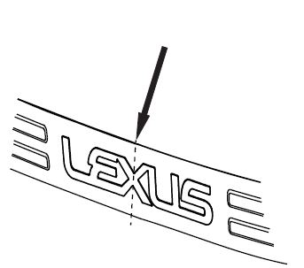
  - Hold the bumper protector about ½” above the surface of the bumper and align the center of the “X” on the bumper protector to the center of the latch on the rear lift gate (Fig. 2-1).
Fig. 2-1
Align the center of the “X” with the hatch latch

  - Keep the bumper protector aligned and lower the center until it contacts the bumper and starts to stick.
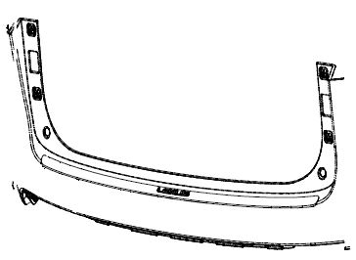
  - Use a rolling motion to lower the rest of the bumper protector from center out (Fig. 2-2).
Fig. 2-2
Roll out the bumper protector from the center

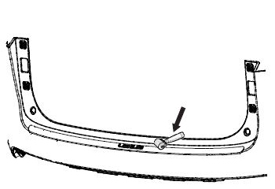
  - Use the hand roller to roll around the perimeter of the part with at least 30 lbs of pressure to ensure complete adhesion of the acrylic foam tape to the bumper surface (Fig. 2-3).
Fig. 2-3
Roll out the bumper protector from the center
Hand Roller

Accessory Function Checks
Check for visual alignment

Check for proper tape adhesion

Vehicle Function Checks

The bumper protector should be visually centered left to right.
The rear edge of the bumper protector should appear visually parallel to the rear edge of the vehicle bumper.
The bumper protector should not extend back out over the rear of the bumper where the bumper surface star ts to transition to vertical surfaces.
A gap of approximately ½ mm is designed to exist between the edges of the bumper protector and the bumper.
No gap is allowed between the tape and the bumper.

Vehicle Appearance Check
After accessory installation and removal of protective cover(s), perform a visual inspection.

Ensure no damage (including scuffs and scratches) was caused during the installation process.
(For PPO installations, refer to TMS Accessory Quality Shipping Standard.)

